**Tasks**

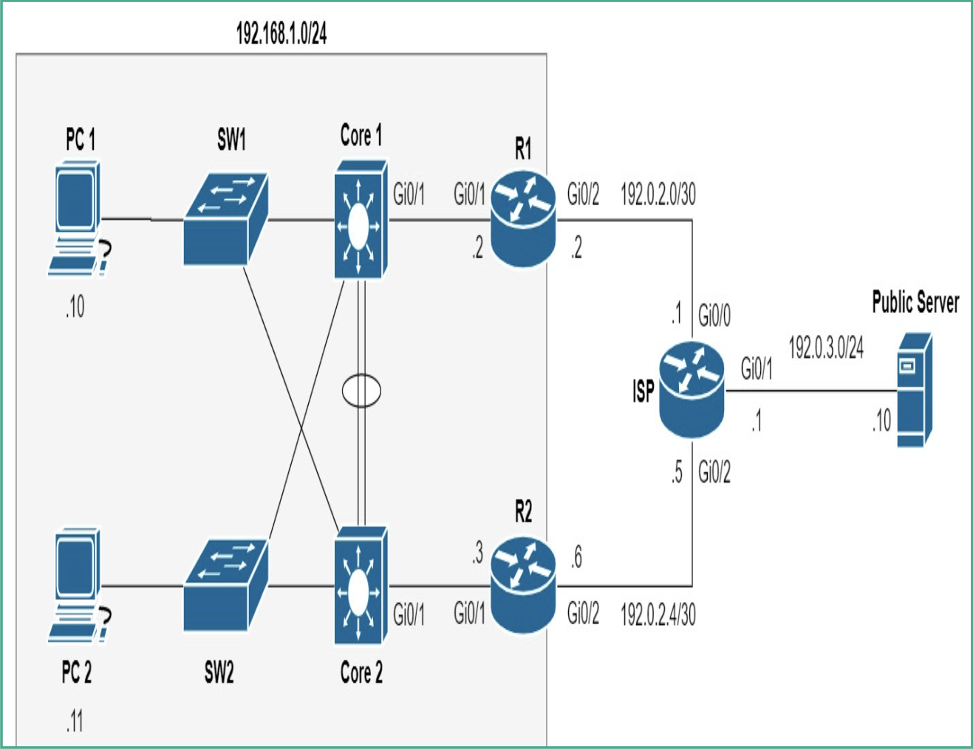

1. Assign the IP address shown in the topology to each device accordingly
2. Each router interface must be configured as shown in the topology
3. Configure the default gateway on both the pcs as 192.168.1.1
4. Ensure the default gateway on the Public Server is set to 192.0.3.1.
5. Create an EtherChannel using LACP between Core 1 and Core 2 using portsFastEthernet with interfaces on your topology on both switches.
6. Configure default Routes on R1 and R2
7. Create EtherChannel between Core1 and Core2
8. Configure HSRP on R1 and R2
9. Verify Connectivity and HSRP